By the end of this 5-hour meeting, we will have:
- Learned about the progress to Master Plan that will compile and catalogue efforts to date and will direct future projects and monitoring,
- Discussed elements of the Master Plan,
- Visited three sites with various erosion issues and mitigation efforts, and
- Defined next steps.

Meeting Location: Shoalwater Bay Tribal Community Center, 2373 Tokeland Rd.
A Virtual Link is available but in-person attendance is recommended.
Please contact Dawn Spilsbury for Zoom meeting link: dspilsbury@watershedco.com

Detailed Agenda
Timing | Topic | Presenter
10:00 – 10:05 | Welcome by the Shoalwater Bay Tribe and Pacific County | Charlene Nelson (Shoalwater Bay Tribe) and Paul Plakinger (Pacific County)
10:05 – 12:00 | Presentation, followed by discussion:  - Status Update on Master Plan Components | Shane Phillips & Younes Nouri (Moffatt & Nichol)  &  Stakeholders
12:00 – 12:30 | Light Refreshments
Site Visits (Maps below)
12:30 – 12:45 | Travel to first site
12:45 – 1:15 | Site #1 – SR 105  46.7274, -124.0505  This is the first parking option. Second parking option is 0.1 mile further down SR 105.
1:20 – 1:50 | Site #2 – SR 105, .4 miles west from Site #1  46.7310, -124.0594
2:00 – 2:30 | Site #3 – Seamobile Rd.  46.7370, -124.0771

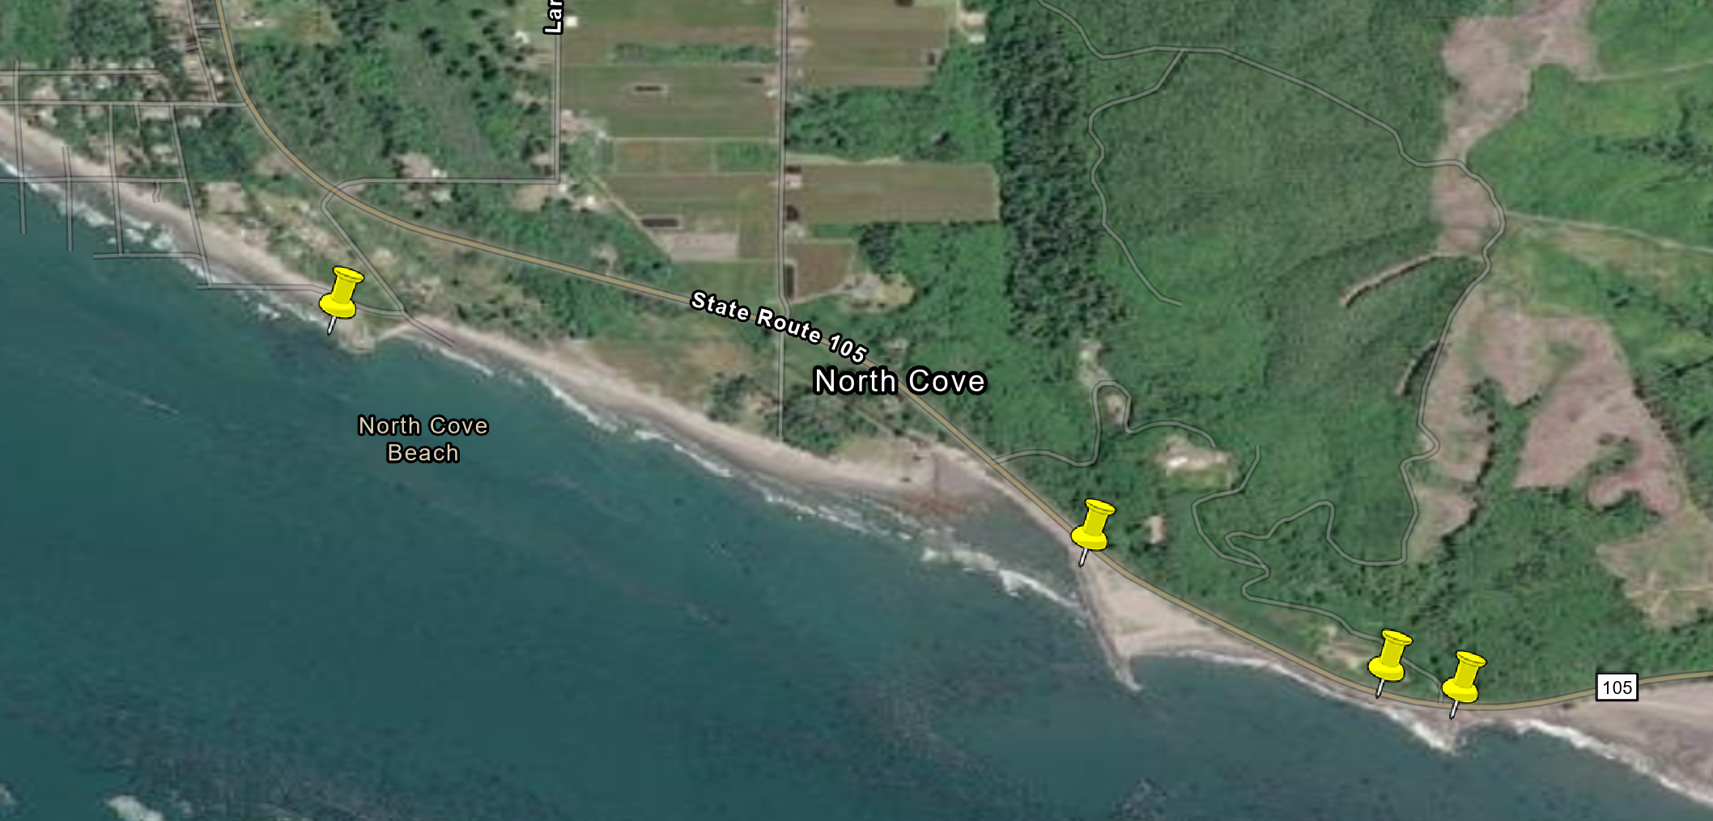
Stop #1
2 parking options
Stop #3
Stop #2

